8.7

Monday, August 07, 2017

For trading, always cut to comfortable positioning that has no element of emotions in it.

Focus on pm only in weak markets.

Focus on index and hedge am with futs.

Trading positioning should not seriously harm utility.

Some analysis:

Low close on Friday is not compensated the next Monday.

So buying on a Friday low is not a good strategy which means it is not followed in the long term, there is no compensation.

Low rebound on Friday means there should not be any buying on Thursday lows.

This is completely in contract with tues pm, there is tues and weds which both offer good return potential. Therefore market strength is explained by this.

That's why Thursday crash is sometimes continued by fri crash.

Actual ptf change is down to 470k.

The following describes the pnl.

First, this means that Monday should not carry big position as mtm is very negative.

Monday you should trade at the close mainly to minimize trade pnl.

Tuesday has both very good mtm.

Wed follows suit. Thurs and Friday you almost make no money in total. You should have leverage on for Tuesday and ignore mon, thurs and fri.

Observe the following mtm and trading patterns:



1. Monday’s low mtm means no buying on Fri.
2. Tuesday never sell before the close. Can buy aggressive.
3. Wednesday never sell before the close. Buying yields not much.
4. Thurs control pos, no buy no sell.
5. Friday no much advantage.
6. For Tues-Fri, sell at the close if you want to sell.
7. Buy Monday close, tues, wed.



**周1买入，当天亏钱，周二赚钱。（总体+17万）(should buy at close)**

**周2买入，当天赚钱，周三赚钱。（总体+13万）（should buy）**

周3买入，当天平，周四不赚钱。（总体+2万） (should not trade aggressively)

周4买入，当天亏钱，周五不赚钱。（总体-5千） (should not buy)

周5买入，当天赚钱，周一亏钱。（总体-3万） (should not buy)

1348：

Selling pressure is not much here. Vol is reduced. Can pick up some pos tomorrow and hold until wed. Once selling pressure is reduced.

走的很稳。Selling pressure reduced at a regional low.

After close:

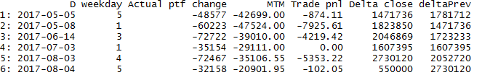

1. Examining the crash lower than -30k. First is fri-mon continuation of 雄安 stocks. Previous delta was a whopping 1.8m at the end of thurs.
2. 6/14 was a big cap melt down, a mid week crash is not very common. This doesn’t have too much insight for future trading.
3. 7/3 weekend exposure is too big.
4. 8/3 8/4 was big caps crash, mon opened with panic. The closing delta on thurs was appalling at 2.7m. Playing with leverage through a thurs-Fri-mon crash is nightmarish. Even thurs delta is too big at full position, should cut throughout the day.
5. Another observable trait is MTM is bad which is a result of previous day delta accumulation.

Avoid the first meltdown is key. Do not accumulate at regional highs. Do not accumulate on Thurs/Fri.

Delta:

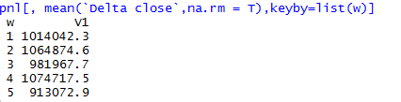

Apparently Friday is overemphasized in the trading mentality. It shouldn’t be. Fri hurt twice already and mon is not suitable for carrying big position through. You tend to overbuy on thurs and cut on fri due to fear of the weekend, then buying on thurs is already a big mistake. (if fri turns bad the negative consequences create negative externality and once fri drops your action set is concave (dropping, gotta cut loss at the lows to avoid Monday crash))

**Some misc stuff on reflection**

各方面问题的成因：

1. Weather in van
2. Speech difficulty
3. 2004 return to Asia, the sunshine hours wouldn’t start to pick up until May
4. 2006 7 6 panic attack
5. 2007 Apr glasses break and coughing for 4 months
6. 2013 May Vancouver pneumonia. Got a cold on the plane.
7. 2017 Jun Taiwan trip, incessant rain, palpitation, after coming back, pneumonia.

The weather was a main culprit. The school was not a good school and the city was small and offered little activities. There was no opportunity to read any literature. There was too much msn and very little outdoor activities. There was no chess club.

In Toronto same pattern ensued. The weather was not good in the winter.

In short:

What should be done is

1. Stay in a place with good weather (Taiwan was a counter example this year, the non stopping rain was not good, heart palpitation was bad.)
2. Grow main competitive advantage. Become an expert in one single area. No need to be a master of all trades. Build extremely good tools in the field.
3. Give up useless stuff.
4. Weak emotional state caused by women was exploited, but that wouldn’t last for long.
5. Limit stuff like instant messaging/limit presence in the virtual world/limit moment posting/attention seeking behavior
6. Technology is super important. Be as advanced as possible in the technology you are using. Rstudio, netbeans etc. Recent study on R packages has paid off, now chinaTrading package is much more useful than the previous pile of junk.
7. Interaction with people usually doesn’t pay off, limit these, especially materialistic, too money oriented people. People don’t change much in a short period of time, it is a waste of time to interact too often.

What was your feeling at U of T?

1. The courses were difficult to score high on as they were social sciences
2. I was obviously more interested in computer science
3. There was obviously more resources in engineering. Bahen center was nice. Commerce classrooms were not in rotman and they were in the basement of a college dorm, this is how the univ viewed the program.
4. Econ was not interesting. Computer science was obviously more interesting.
5. Deeply affected by health problems in Toronto.

Useful stuff I did

1. Computer science course at u of t – started programming
2. Job at rbs – started on vba coding.
3. Job at socgen new York – did a lot of vba coding for that year, correlation graphing
4. Job at ms – learned about the basics of trading, especially pnl classification
5. Job at socgen hk: also did some programing

2015-11-18

Started on java. Read thru IB api, built tools based on IB platform.

2017

Mar: using excel to automate a lot of daily tasks. In haikou I started building vba automation tools.

In May I started making R tools for morning tasks.

Using super/extends. Wrote a lot of java code.

R: started using packages to group all functions and make morning task more efficient.

Constant pursuit of knowledge is good.

In 九毛九 in haikou, I understood why I need to use swing.invokeLater for swing objects due to swing thread unsafety.

In 大家乐 in hk, I figured out how to place script in the inst folders to avoid it being compiled.

I understood import/export in namespace as a result of biting through that book in center book mall.

I bit through a lot of Java books ( have not bought any 1 of them) since Nov 2015, in the order of maybe 50 books, building the foundation of java programming.

Keep 总结 on how to improve trading, like weekday and position sizing etc.

Started using Git in Jun 2017. Migrated Java, R, R packages and trading folder all to git, profounding increasing the stability of the system.

Continue to climb tech tree, keep the same assiduity in record keeping in trading.

8.8

Futs was lower in pm due to neg correlation with Monday’s close, trading pos was under water as well as mtm position. Cyb has performed better recently.

Still 2% from the previous highs. Can hold the position at this level.

**Aug 9**

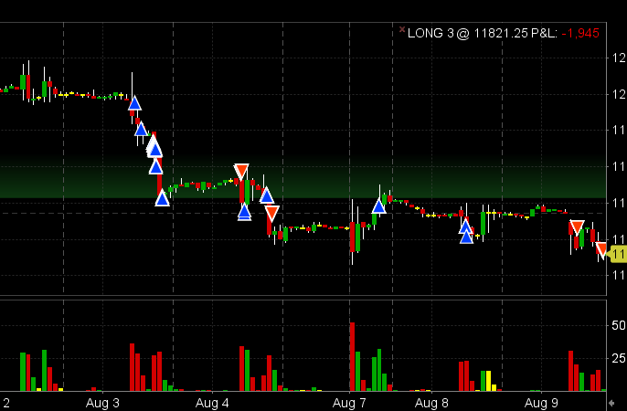

The above is the future trading chart, as one can easily see the performance has been absolutely appalling. 8/3 was a changing point in the game where thurs crashed followed with a fri that broke the new lows. This week was characterized by a brief Mon rally and a weak tues rebound followed by a pm kill on wed. The overall trend is clearly bearish.

I dropped a lot of pnl playing long. Some shorts will need to be done.

1. AM shorting to hedge against long etf pos (if ytd didn’t close at the absolute lows, hedge out AM)
2. No shorting when ytd was absolute lows.
3. Pm shorting when previous pm was closing at the highs
4. General shorting on mon/thurs/fri with weak probability distributions (on the cash side there shouldn’t be much exposure in the first place)
5. The only advantage left is some negative pm corr advantage. This is the sole tradable stuff now. Overnight risk, AM risk should all be hedged out. Even this advantage shouldn’t be traded with big position. Gotta use small pos to make back the 3.3% losses.

In general, shorting should be exclusively used for hedging. Markets are too weak to long now.

8/10

As per discussed yesterday,

No leverage, no overtrading on TH/F/M, don’t move pos, max pos is full, position cutting at end.

8.11

Market crashed in US overnight, futs down 1%. Vix rose by 44% overnight.

US is needing a correction at this point.

If ptf loss exceeds 6%, cut all.

Going forward, need to set up rules regarding the relationship between recent pnl loss/drawdown vs. maximum positioning.

Following a retreat of 3.3% from the highs, cannot put on leverage, need to limit overnight risk.

As previous said, no leverage at this point.

Purely take advantage of PM advantage. Hedge overnight and AM risk.

* 1. 12:08

**On probation**

Liquidate all pos before the close.

Next three weeks no trading. Losing too quickly.

Down 5% a week. Hedge before the close and liquidate all ETFs.

Only keep 长江电力 for tax reasons.

The liquidation came earlier than expected for this month. Only took 1 week to reach liquidation order.

Going forward, 3% down, rest for 1 week.

6% down, for until end of the month.

Reflect on what you did wrong this month, every trade, position sizing.

Build infrastructure and tools and run analysis in the meantime.

Hedged all risk to 300k and locked in the loss this today. Probation until early sept.

**After market:**

The cutting was done well as it saved 5k. When back from probation, you should make sure to hedge better. Especially AM movements.

**8.13.2017**

Hedging out wed-fri AM is crucial as can be seen from the following. Exactly as what the research shows, Monday is not a worthy day to trade. Tues is good. Wed: hedge out am and play PM. Thurs: hedge out am, pm is weak and not very good to trade. Fri: hedge out AM and PM offers nothing.

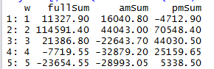

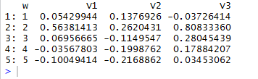

By month:

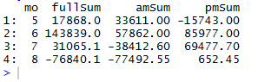

Net:



The above shows AM is the real strength indicator. In an upward market, AM return will be positive. Negative pm return will be compensated.

All throughout july, the need for covering am is more and more urgent, which means the market already cannot hold up. This foreshadowed the august misery. Jun was the only impressive bull bear this year.

When losing a lot in AM, this shows things are bad.

Observe the following table:

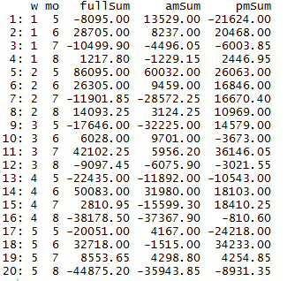

Monday was only strong in june when it was full on bull market. Negative am on Monday is an indicator of bear market.

Tues: Tuesday was powerful in May and jun in bull conditions. Jul weak AM was telling. People are selling.

Wed: Wednesday AM is either super weak or flat, hedging wed am is necessary.

Thur: thurs AM is bad in general except bull market. PM is not strong as there is no rebound that carries a conviction to the next weekday.

Fri: Fri pm was strong in jun as people had high expectations of next week. In aug fri morning was filled with liquidation.

**Takeaways:**

These four months are rather typical of a bull-bear cycle. In early cycles of bull, there are buyers in am but sold off in the pm, the PM will be compensated for in the next session, markets are in upward trend.

Jun: all out rally with both AM and PM positive. Fri pm is very optimistic with buyers holding pos over the weekend.

Jul: rebounds. People sell off in the AM and rebounds in PM. Overall market felt weak and more sellers than buyers and short term trades always bought the PMs but real sellers always sold AMs. This was the end of the bull market.

Aug: massive AM sells with no pm buyers. PM buyers disappeared because there would be too much loss the next AM. There are mostly all sellers in the market with no long term interest nor short term trading interest. The fall must continue until AM shows livelihood.

In anycase, AM delta should be cut aggressive from wed-fri. Fri you should not have any pos to play rebound. Tue-Thur’s rebound can be played. Mon keep all day pos light.